Mounting
These methods are called in the following order when an instance of a component is being created and inserted into the DOM:
- constructor()
- static getDerivedStateFromProps()
- render()
- componentDidMount()

- 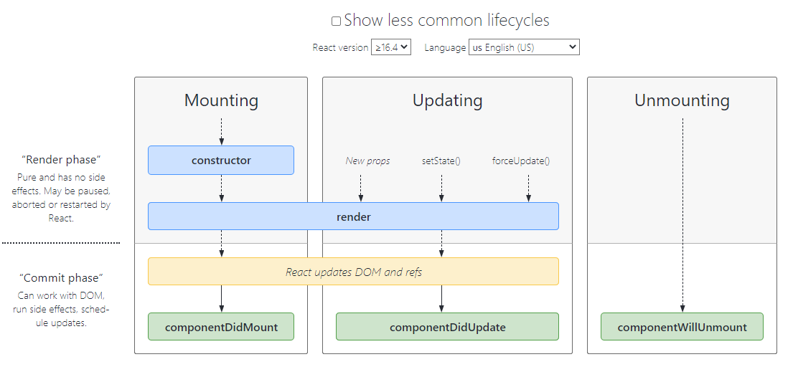

در داخل استرینگ اضافه کردن مقدار متغیر :
Axios
.get (`https://jsonplaceholder.typicode.com/posts/${this.props.id}`)

